**Iron Fist Season 3: Cancelled!**

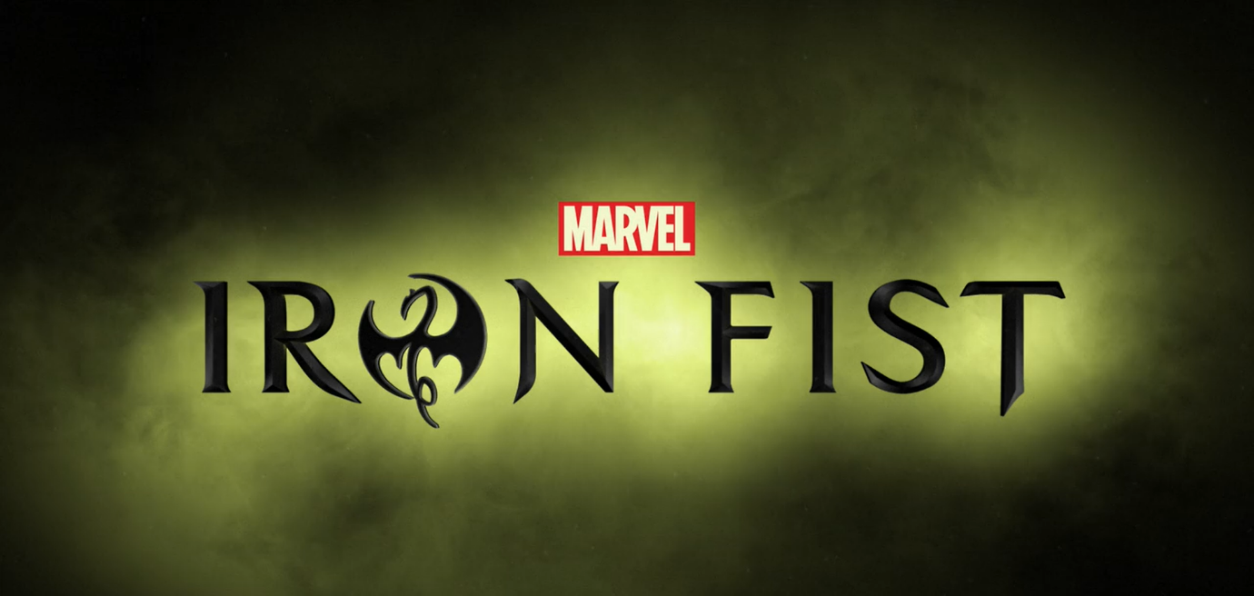

After such a thrilling (improved than **season 1**) **season 2**, fans were eagerly waiting for **season 3** of Iron Fist but it wasn’t approved to **Netflix**.

Candidly speaking, after such a catastrophic **season 1,** Production team of **Iron Fist** worked a lot on the next season and came up with an improved, better **season 2** than anticipated after looking **season 1**. They improved so much leaving the past behind, that it seemed, they received the place amid the top **Netflix *Marvel Cinematic Universe (MCU)*** *movies* fame and recognition.

Still, it seems that not so many people saw the *season 2* because of such an awful *season 1*, because *Netflix* gave the statement that *Iron Fist* is postponed, and it won’t be coming back for *season 3*. This’s the *Marvel*’s announcement:

“*Marvel*’s **Iron fist** will not return for a *third season* on **Netflix**,” *Marvel* told *Deadline*. “Everyone at *Marvel Television* and *Netflix* is proud of the series and grateful for all of the hard work from our incredible cast, crew and showrunners. We’re thankful to the fans who have watched these two seasons, and for the partnership we’ve shared on this series. While the series on *Netflix* has ended, the immortal *Iron Fist* will live on.”

Reasons were the lower no. of viewership of the show compared to other shows on *Netflix* and the conflict between *Marvel Universe* and *Netflix*. It was unprecedented because *season 2* ended on a vivid note directing towards another inevitable **season 3**. There were some spoilers about the leading **cast** like **Danny**will upgrade his shooting powers and **Colleen** will be the new **Iron Fist** which led the fans to think that another Season will come for sure. But for *Netflix*, it’s quite clear that it’ll not show any *movie* or show with lower number of viewership, so it’ll cancel that for sure even if that *movie* or show’s production team and company has a big name and fame in the industry.

One can’t completely blame the watchers of the show to be at the fault for not seeing *season 2* and turning up the viewership because even though *Iron Fist* production team improved a lot in *season 2* from *season 1* but still they couldn’t make it big up to the expectations of viewers, they’ve in general with other **Marvel** *movies*. But it’s highly likely that characters from **Iron Fist** will keep on coming in other movies on *Netflix* as per its statement. But still it’s unfair to leave a show in its mid-way without wrapping things up. *Netflix* must have given a chance to the creators of *Iron Fist* to complete and wrap up its story, binding up all the characters together. 

On *October 12, 2018* **Netflix** announced the cancellation of *Marvel series* **Iron Fist** despite *Marvel* willingness to continue it on the platform. There were reports to *Deadline Hollywood* that **Disney** is planning to *renew* and *revive* the Iron Fist series along with other cancelled *marvel series* streamed on *Netflix*. But according to *Variety* reports the Iron Fist characters can’t appear in any other non-*Netflix films* or *series* for at least two years as per the original agreement between *Netflix* and *Marvel*. So, there’re chances for the revival of the **Iron Fist series**. Craig Erwich, Hulu’s senior Vice president gave the statement in February, 2019 that the streaming service was open to revive the cancelled *Marvel series*. So now it depends on the creator what they wish to do. But as of now there’s no reports for **season 3** creation. But there are chances that *season 3* will come back though that seems to be quite unusual. But still you can watch the recap (*trailer*) of the previous two seasons 😊

https://www.youtube.com/watch?v=f9OKL5no-S0